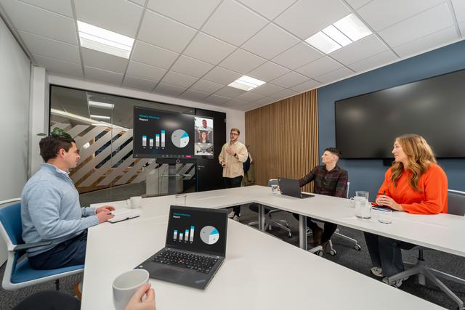

# Sennheiser Unveils Plans for Cloud-Based AV Management Platform

**Currently in development, the new platform for centralized set-up, control and management will officially launch in early 2026**

***Wedemark, 11 June 2025* – Sennheiser, the first choice for advanced audio technology that makes collaboration easier, today announced a new cloud-based platform designed to empower AV and IT teams with secure, flexible, and scalable device control across a wide range of environments. The solution is set to transform the way teams configure, monitor, and manage Sennheiser devices - from small meeting rooms to high-impact spaces.**

**Register your interest to receive updates as we move toward launch by** [**completing the form found here**](https://www.sennheiser.com/en-us/cloud-announcement?utm_source=email&utm_medium=email&utm_campaign=cloud-announcement.)**.**

Built with remote oversight and flexibility in mind, the platform centralizes control in a future-ready, intuitive interface - simplifying workflows and enabling efficient device management across multiple locations. Created for IT and AV managers and system integrators, the platform streamlines device management across enterprise, education, and corporate settings. Whether managing large-scale installations or optimizing remote operations, the solution will keep teams connected, efficient, and in control.

**Remote Management & Monitoring**

AV teams can manage devices from anywhere with real-time diagnostics, alerts, and updates. Flexible account and location management features make it easy to organize users and devices, while role-based access improves collaboration and security.

**Simplified Deployment & Configuration**

Set-up is hassle free and can be completed via a web browser, with no installation required. This enables quick deployment and streamlines workflows for integrators and IT professionals alike.

**Effortless Control & Future-Ready Flexibility**

The centralized control hub for Sennheiser devices will scale with the evolving needs of AV and IT teams - supporting everything from single rooms to multi-campus environments.

**Security By Design**

Built with modern IT security practices, the platform will use robust encryption and authentication to protect data and devices. GDPR compliance and strict data privacy measures are part of the foundation - ensuring security and peace of mind.

“While still in development, our powerful cloud-based platform for AV and IT teams will make device management simpler, more flexible, and more accessible,” said Kai Tossing, Head of Product Management, Business Communication, Sennheiser. “The new platform will be a significant step forward, as we take many of the benefits users of our Control Cockpit software have experienced and make them available on a broader scale.”

For more information about Sennheiser and its solutions, visit [www.sennheiser.com](http://www.sennheiser.com)

**About the Sennheiser Brand – 80 Years of Building the Future of Audio**

We live and breathe audio. We are driven by the passion to create audio solutions that make a difference. This passion has taken us from the world’s greatest stages to the quietest listening rooms **–** and made Sennheiser the name behind audio that doesn’t just sound good: It feels true. In 2025, the Sennheiser brand celebrates its 80th anniversary. Since 1945, we stand for building the future of audio and bringing remarkable sound experiences to our customers. While professional audio solutions such as microphones, meeting solutions, streaming technologies and monitoring systems are part of the business of Sennheiser electronic SE & Co. KG, the business with consumer devices such as headphones, soundbars and speech-enhanced hearables is operated by Sonova Holding AG under the license of Sennheiser.

[www.sennheiser.com](http://www.sennheiser.com)

[www.sennheiser-hearing.com](http://www.sennheiser-hearing.com)

**Global Contact**

Jeffrey Horan  
Global PR/Media Manager Business Communication  
jeffrey.horan@sennheiser.com

+1 860-598-7539